1. Write a Python Program to Convert Kilometers to Miles by taking user input.

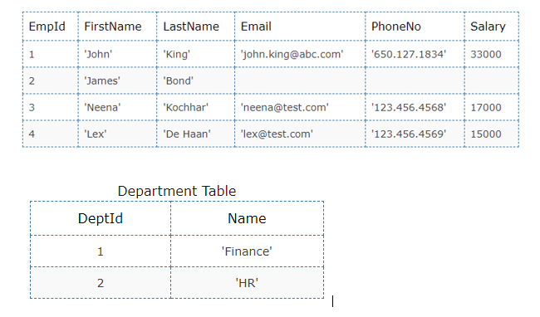

Read the following Employee table to answer question:

2) Find details of employees with id should be 1 and salary should be greater than 20000.

SELECT Empid FROM employee

WHERE salary>=20000;

Write machine learning code for any provided datasets.

1) <https://github.com/dsrscientist/dataset4/blob/main/Harry%20potter.zip>

5. Write a program to print the squares of odd numbers and cube roots of even number from the list given.



3) Find details of all employees whose department is HR.

SELECT emp_id, First_name, dept_id

FROM employees

WHERE dept_id IN (1, 2);

Write a program asks for City name and Temperature and builds a dictionary using that Later on you can input City name and it will tell you the Temperature of that City.

1. Write a Python Program to Convert Celsius To Fahrenheit.

Given a Python list. Turn every item of a list into its square.

4. Rename key city to location in the following dictionary

sampleDict = { "name": "Kelly", "age":25, "salary": 8000, "city": "New york"}

Expected output:{ "name": "Kelly", "age":25, "salary": 8000, "location": "New york"}



Read the following Employee table to answer question:

1) Find salary between 15000 and 20000 including both values from employee table.

SELECT * FROM employees

WHERE salary BETWEEN 15000 AND 20000;

2. Write a Python Program to Convert Kilometers to Miles by taking user input.

km = int(input("Enter the value in kilometers: "))

ratio = 0.621371

mi = km * ratio

print("The entered value in Miles: ", mi)

Enter the value in kilometers: 10

The entered value in Miles: 6.21371